Energy Storage Systems Summary (Thermal)

**Global Energy supply**

**Oil:** The world’s oil reserves were given as 1,354 billion barrels in late 2009. The reserves have never been higher: they have more than doubled since 1980 and have risen by a third in the last decade. Half of the increase since 2000 is due to the opening up of Canadian oil sands. Such unconventional oil reserves (and also unconventional gas reserves) are often found in ecologically sensitive areas, and partly under problematic conditions.

**Gas:** Compared to the oil reserves, the gas reserves can be judged as productive. The definitely confirmed reserves have increased steadily in recent years. At the end of 2008 they were estimated at 184 trillion cubic meters, which is about double the assessment of 20 years ago. With today’s production rates, this results in a static lifetime of 58 years.

**Coal:** The coal resources are estimated at around 82% of all non-renewable energy resources. The reserves are about 1,000 billion tons, enough to cover the current demand for another 150 years. In contrast to conventional oil and gas, coal reserves are geographically diversified: the largest deposits are located in the United States, China, Russia, India and Australia.

**Uranium:** The uranium reserves are now estimated at around 5.5 Mio tons. With an annual consumption of around 66,000 tons these reserves are sufficient to cover the current demand for approximately 83 years.

**Renewable Energy:** Like many other studies, the WEC (World Energy Council) comes to the conclusion that the technical potential of renewable energy exceeds the world needs many times. There is no question of the potential, but the opening up of it is crucial. The IEA (International Energy Agency) assumes that independent of which scenarios are considered, renewable energies will see a strong increase by 2035.

**Swiss Energy Strategy 2050**

**Going on as up to now:** Autonomous trends of the past will be observed and updated according to the current market conditions. Further on, they will be reinforced by the energy policy instruments, which are either already in force at the present time, or planned.

**Policy measures:** The adopted measures drawn up by the Federal Council on 18 April 2012 will have been analyzed, giving special consideration to their legislative basis (e.g. provisions for building standards, CO2 emission limits for new vehicles).

**New energy policy:** The targeted policy variant, ”New energy policy”, examines how to achieve the target of reducing energy-related CO2 emissions in Switzerland to around 1.5 tones per head by 2050.

*On 25 May 2011 the Federal Council decided to abandon new nuclear power plants (no new constructions, continuous operation of existing power plants, as long as the reliability is ensured) and confirmed the turnaround in energy policy. The contents of this turning point are:*

1. Reduction of the consumption of energy and electricity,
2. increasing the share of renewable energies,
3. ensuring access to international energy markets,
4. strengthening international cooperation,
5. strengthening of energy research,
6. leading role of the public sector in transforming the energy supply and
7. expansion and conversion of electricity grids and energy storage.

***By 2050, Switzerland seeks to be a 2000-watt and a 1-1.5 ton CO2 society*** *(in comparison, today each and every Swiss consumes 6400 watts of power and produces around 6 tones of CO2 per year). Thus, energy storage will play an important role in the framework of the Energy Strategy 2050. Since electricity (or energy) production from supply-dependent energy sources not necessarily coincide with the consumption, there is an increased need for intermediate storage of electricity (or energy).*

**Storage Benefits**

*It is important to distinguish between energy storage applications and storage benefits. A benefit can be a revenue stream, a cost reduction or an avoided cost. A technology implemented in a specific application can provide several benefits.*

**Industrial peak shaving** aims at flattening the power demand (reducing power peaks) of the industrial site and is of particular interest for applications characterized by a strong variation of energy demand throughout the day. The storage unit is typically designed to charge during off-peak hours and supply the power during peak-demand hours (see Ice Storage case study). The revenue streams for a storage in such applications can result from: (1) reducing cost by consuming lower-priced, off-peak electricity (2) reducing investment cost by decreasing equipment size (e.g. heat pump, chiller, cooling tower etc.) and (3) decreasing grid-connection fees which are proportional to the maximum power consumed.

**Seasonal storage** refers to the storage of heat, cold or electricity for periods up to several months. It can be broadly defined as a system that stores energy during one season to deliver it in another season and therefore reducing seasonal fluctuations in supply and demand. A typical example is storing heat during the summer in an underground thermal energy storage (UTES) using solar collectors to release it in the winter when the solar irradiation is lower but the heat demand is higher.

**Waste heat utilization** refers to the storage of waste heat which can’t be utilized at the time of its production and would normally be rejected to the environment. The energy stored can be used at a later point when it is needed. A typical example is storage of process heat for batch industrial processes, where the process heat from one batch can be stored to heat the next batch, drastically increasing the process efficiency.

**Combined heat and power (CHP).** CHP plants produce fixed ratios of electricity and heat which typically don’t match the corresponding energy demands. Thermal and electricity storages can be implemented in such plants to bridge the gap between supply and demand.

**Types of Energy Storages**

**Energy Storage Classification**

**Energy output.** As discussed in the previous chapter, storage systems are often classified according to the form of output energy. We distinguish between (1) electrical storages (storages that supply electricity),(2) thermal storages (storages that supply heat) and (3) fuel.

**Form of stored energy.** Storage systems can also be classified according to the energy form which is used for the storage itself irrespective of their energy input or output.

**Location on energy system.** Energy systems can be separated in centralized and decentralized (distributed). Centralized electricity storages are larger-sized systems located in the supply and T&D section of the grid whereas decentralized are the smaller scale electricity storages that are located on the demand side and are connected at the edge of the network. For thermal energy storages the term centralized refers mostly to large storages (hundreds of kW to MW) connected to a heating/cooling network (e.g. district heating and cooling), while the term distributed refers to smaller units that are places on the demand side of the energy system.

**Power output.** According to BFE, energy storage systems can be classified according to their power output in micro-storage, small-scale storage, medium-scale storage and bulk storage.

**Response time.** This classification applies mostly to electricity storage systems where response time is often crucial to the type and quality of services a storage can provide. The response time ranges from milliseconds to days.

**Storage period** refers to the period during which the energy re- mains stored before it is released and is related to the discharge frequency. Short term storages (second-minutes) are mostly applied to grid-stabilization applications whereas longer term (hours-seasonal) for energy shifting applications. Longer term storage systems are required to have very low self-discharge and high energy densities (e.g. thermo- chemical, chemical).

**Level of Energy Storage Applications**

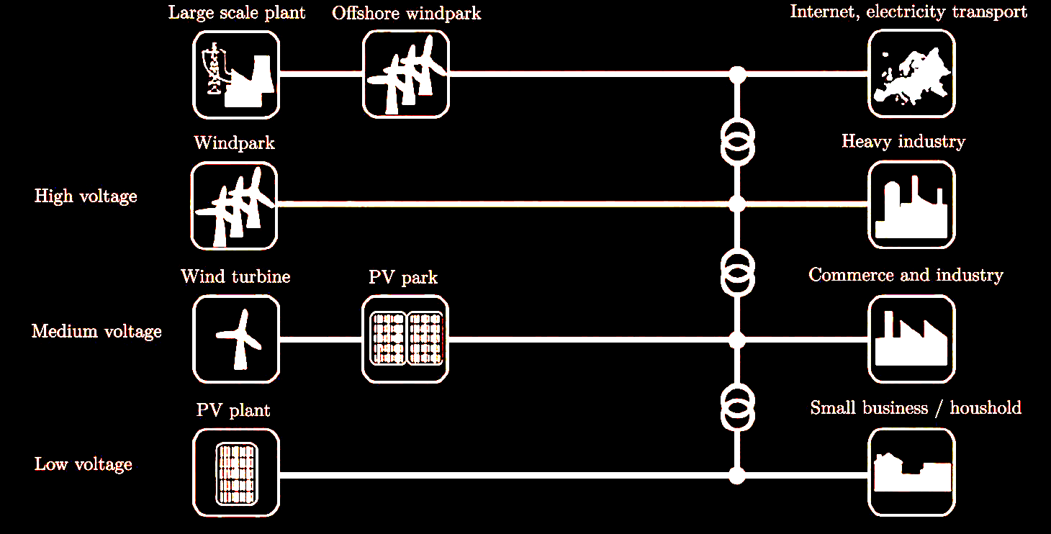

**Energy and Exergy balance**

$$\frac{dE}{dt}=\sum{\dot{Q}}+\sum{P}+\sum_{in}{{\dot{m}}_{in}}{\left(h+\frac{c^{2}}{2}+gz\right)}_{in}-\sum_{out}{{\dot{m}}_{out}}{\left(h+\frac{c^{2}}{2}+gz\right)}_{out}$$

(for TES the velocity *c* and the height *z* are not important and can be neglected.)

Energy balance:

$$\frac{dE}{dt}=\sum{\dot{Q}}+\sum{P}+\sum_{in}{{\dot{m}}_{in}}h_{in}-\sum_{out}{{\dot{m}}_{out}}h_{out}$$

$$Energy=Exergy+Anergy$$

Exergy balance:

Exergy of heat:

Exergy of a flowing fluid:

Anergy of a flowing fluid:

For an ideal gas:

For fluids (incompressible):

**The NTU Method**

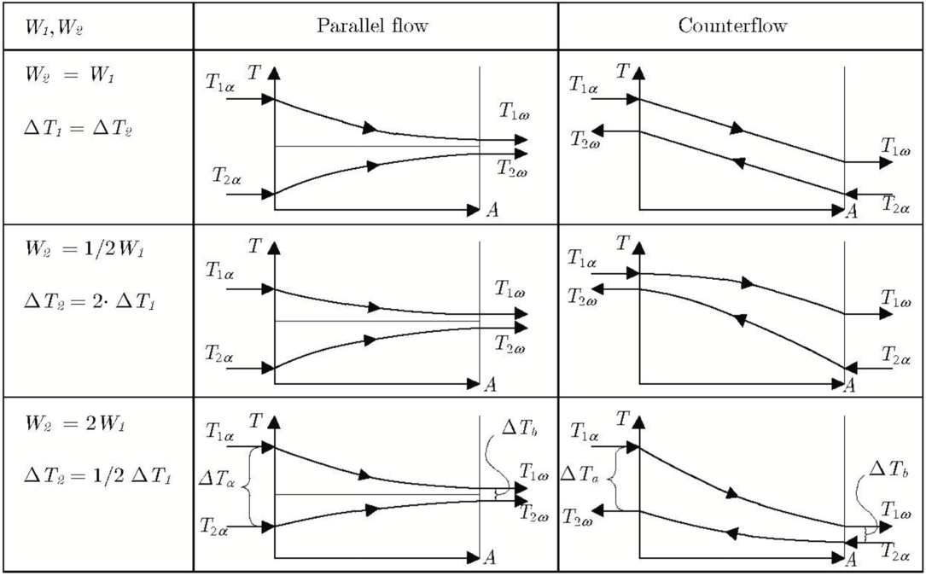

**Stratification**

Energy and Exergy:

Z: total height of the tank

ideal liquid:

Temperature as a function of height only:

Energy and Exergy:

Exergy difference between stratified and mixed:

**Continuous-Linear Temperature-Distribution Model (Zones)**

Energy Storage Systems Summary (Electrical)

|  |  |
| --- | --- |
| Advantages | Disadvantages |
| High capacity, fast charging  Low temperature compatibility  High # of cycles (1000-4000)  Capacity widely independent from discharge current  Low dischargeable | High temperature sensitive (> 45 °C)  Memory effect  Environment, Cd, Cd(OH)2 is toxic  Highly self-discharging  High price (3-5x more than lead acid)  Bad efficiency (in full cycle use) |

|  |  |
| --- | --- |
| Advantages | Disadvantages |
| High energy density  Fast chargeable  Ecological  Low costs  Long lifespan | Low power density  Memory effect (compare NiCd)  High self-discharging  Low temperature  Similar price as NiCd  Worse than Li-Ions (energy density) |

**General Classifications:**

* electrical – others (H2, compressed air, thermal)
* Size: power and energy @ cycles, parameters
* Small – huge (spring of ball point pen – pump storage plant)
* Use: mobile, stationary, balancing, @ better time
* Place: mobile, in house decentral, region, town, central,
* Integration standard: board-battery – ZEBRA – Redox-Flow
* economics

**Definitions:**

* Batteries
* Accumulators: rechargeable batteries
* Supercapacitors, ultra-capacitors, EDLC (el. double layer capacitor), Helmholz, typ. 2.5V: electrical high capacitcapacitors
* Primary cells: energy through unique chemical transformation! Nin reversible process
* Secondary cells: electric rechargeable cells; electricity is a secondary type of energy by reversible process!
* SoC, DoD: State of Charge, depth of discharge in %
* C: unit of discharge current. 1C is a charging current equal to the number of charges of the storage in [Ah]. 3C : charged in 20min., C/5 charged in 5h.
* CV, CC : charging profiles, means constant voltage, constant current respectively
* Full cycles, shallow cycles 🡪 important for life time
* Thermal Runaway: positive thermal feedback loop (warming up / explosion)
* Charging profiles: done by components, Ics or CCS Computer Charging System: model calculation on a chip

**Repetition Infrastructure:**

* Renewables are important, but...
* Even more important are
* HV-Grid and distribution grid and Energy storages!
* Rather laying in the ground?
* DESERTEC?
* Or completely different: only decentralized power supply?

|  |  |  |
| --- | --- | --- |
| Step 1 | Select the module rated voltage | DC-Link Voltage? Is there any DC/DC converter? |
| Step 2 | Select module capacity for given energy capability and efficiency | 1.Energy? 2.The power may cause reduction of cycles 🡪 therefore it may be necessary to oversize the capacity (shallow cycles) |
| Step 3 | Load- and operational profile for determination of life-time and cycles? Mobile or stationary? 🡪 Fixing the technology (costs ?) | Load profile: concerning 1 simple charge- and discharge cycle! Operating profile: cycles over the lifetime |
| Step 4 | Number of series connected sub-cells |  |
| Step 5 | Capacity of single cell? Parallel modules? | Take in account that modules can be connected in serial line or in parallel! |
| Step 6 | Thermal design according to profiles above. | Simulation may be necessary if profile is complicated! |
| Step 7 | Integration aspects, voltage balancing, security, filtering, BMS control, communication, weight, packaging | 🡪 To be solved |
| !!! | For all steps: | 🡪 Iteration may be necessary |

**Definitions and Examples:**

Smart-Grid=

Smart grid is a type of electrical grid which attempts to predict and

intelligently respond to the behavior and actions of all electric power users connected to it - suppliers, consumers and those that do both – in order to efficiently deliver reliable, economic, and sustainable electricity services.

(Wiki)

e.g. Enel, 2005.

e.g. US, the city of Austin, since 2003,

e.g. Boulder, Colorado 2008.

e.g. Hydro One, in Ontario, Canada 2010, 1.3 million customers

e.g. The City of Mannheim in Germany is using realtime Broadband

Powerline (BPL) communications in its Model City Mannheim "MoMa"

**DR Demand-Response, Electricity Pricing:**

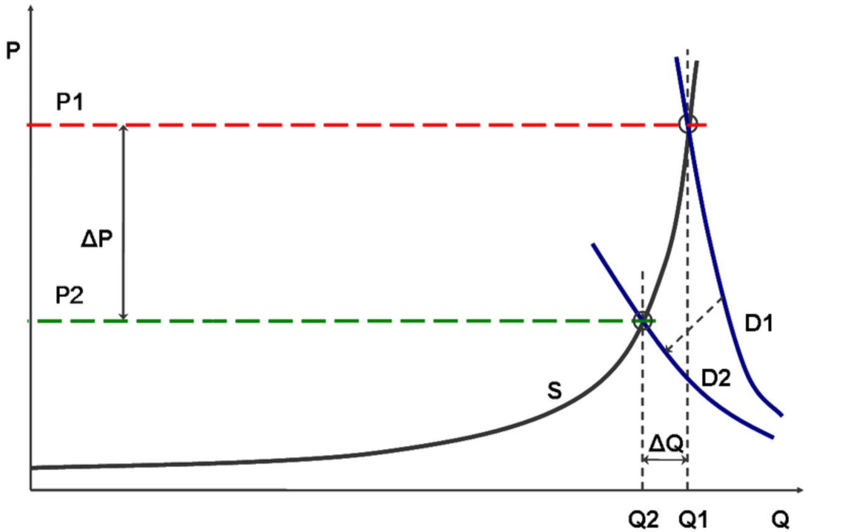

Explanation of demand response effects on a quantity (Q) - price (P) graph with the curve S for the supply side. Under inelastic demand (D1: high demand of needed power) extremely high price (P1) may result on a strained electricity market. If demand response measures are employed the demand becomes more elastic (D2: less demand for delta Q, e.g. storages). A much lower price will result in the market (P2).

It is estimated that a 5% lowering of demand would result in a 50% price reduction during the peak hours of the California electricity crisis in 2000/2001. The market also becomes more resilient to intentional withdrawal of

**When do batteries make sense for PV-plants?**

* Peak shaving
* Energy market
* Best tariffs, but only for about one day
* Less costs for a better infrastructure
* Interests of stakeholders

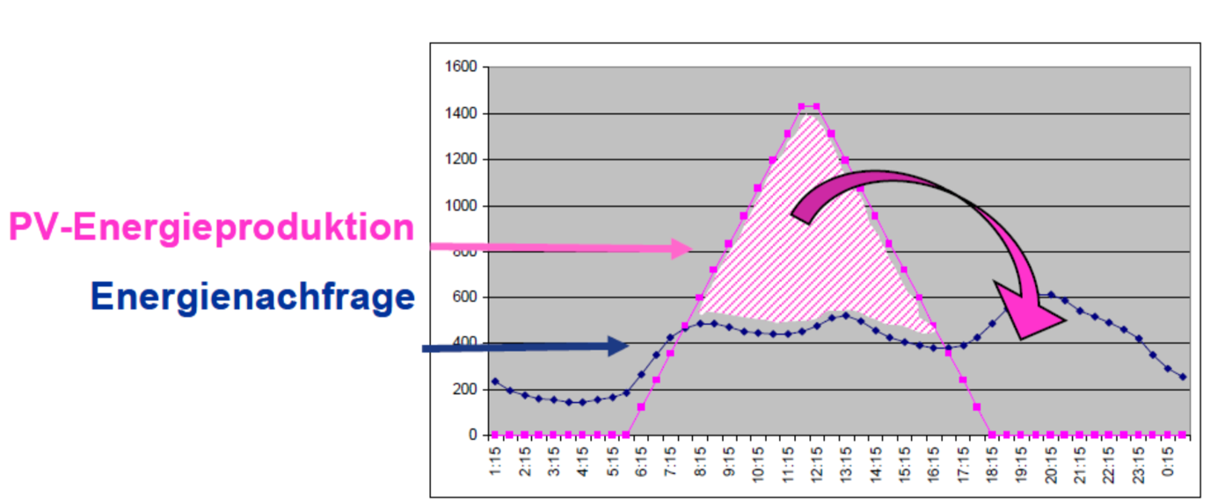

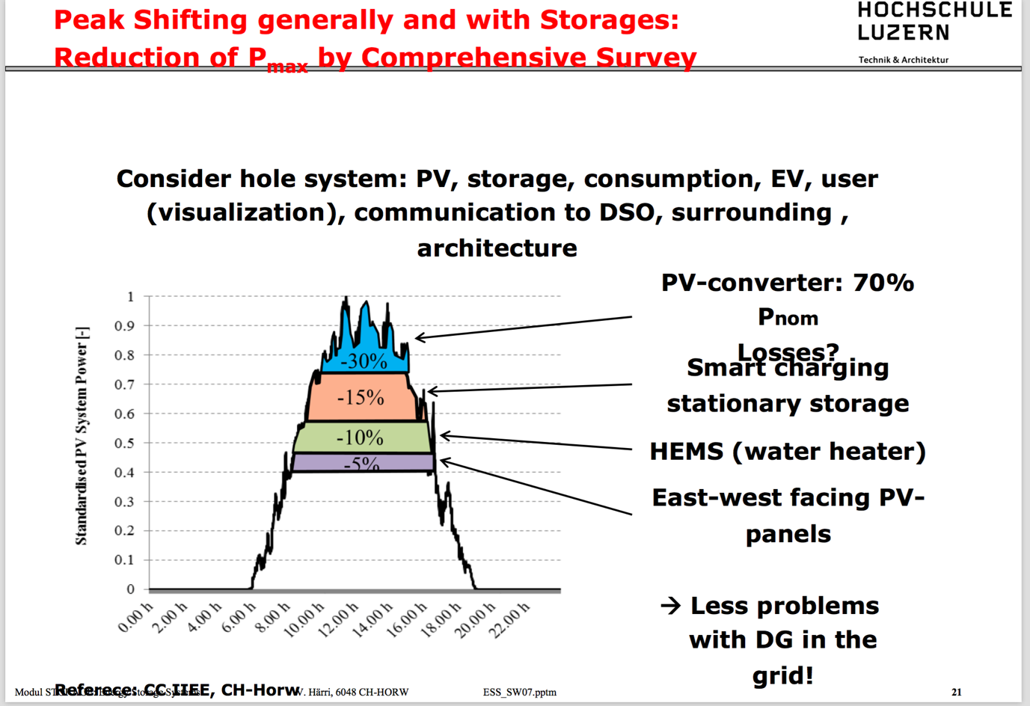

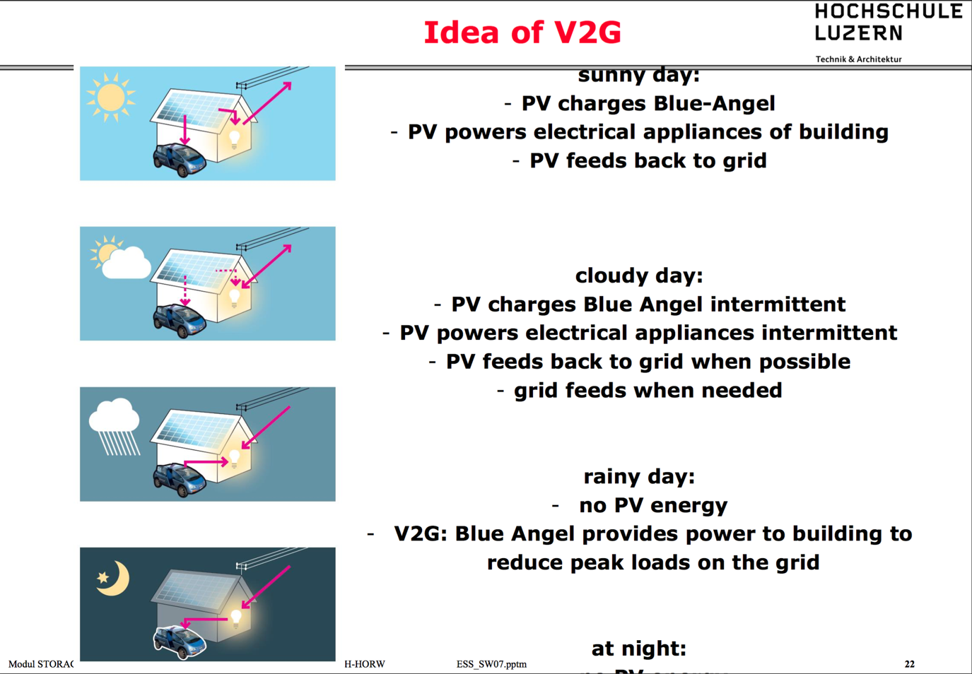

**Loading energy storages**

**charging process of Li-Ion cells:**

1. Detecting if cell is correct
2. Always control if cell crosses a minimal or maximal voltage
3. Charging with low current (pre-charging) till voltage reaches 3.2V
4. Normal charge with indicated current (1C..5C) 🡪 CC, then at ≈4.2V
5. CV charging current falls exponentially
6. Voltage constant

**Battery technology:**

Security lighting in cinema: Lead Acid

Stationary battery for buffering PV-energy in a suburb: Redox-Flow

Electrical bike: Li-Ion (LiFePO4)

Storing a huge amount of electrical energy: compressed air, pump hydro plant

Remote controlled model air-planes: LiPO

**Design of SCAP Modules:**

1. For batteries: energy is nominal voltage times charge (V*Ah),
2. Small voltage (~2V) 🡪 serial connection! Charge balancing, but voltage of SCAPs is not constant, therefore...🡪 Energy flow control design of serial/parallel modules
3. Overvoltages have to be prevented
4. Parameter deviation (production, temperature, longtime parametric drift)
5. Durability: voltage level low over time!
6. Reversions of voltage at discharging versus zero have to be prevented
7. "By-Pass" function for short circuit and unpredicted circuit opening?
8. System aspects: planning modularity of SCAP-storages “
9. Integration concepts, e.g. SAM (Super Accumulator Module), Ultrabattery...
10. 10.Energy management (intelligence) works together with a master system

**Designing SCAPs: boundary conditions:**

1. The influence (power dissipation) of internal resistance is given by R·I2
2. Current load profiles of the storages: load profile (typical cycle), operating profile 🡪 energy and power density?
3. Cycle numbers for typical application, as well as aging
4. Design, dimensions and weight
5. Temperature range
6. Load management (energy flow, balancing, monitoring, MMI, etc.), protection concept (overloading, over-discharging, ...), capacity detection, over- and under-temperature protection, SoH detection (state of health)
7. System integration: EMC, fuses, contactors, power supply, interaction storage with intelligence of overall system, expandability (modularity), universality, simple integration, redundancy, combination of different systems and compactness are the important factors.
8. System-specific specifications, costs!
9. Environmental compatibility

**Design Example:**

*A 12V car starter motor pulls about 120A. Assume that there is only the SCAP Module (no battery) and that the starting duration is max. 5s. The SCAP module shall use the 12V range of 8.5V to 13.V*

1. Design a supercapacitor module by means of Maxwell Boost cap SCAPs with enough energy and working within the 12V board supply system boundaries. Procedure?
2. Compare the SCAP solution with a battery solution concerning the efficiency during the starting of the motor. Assume a OPTIMA battery of the type “OPTIMA® YellowTop S 2,7 & R 2,7” with 38Ah, which shall be in a SOC showing an internal ESR of 10mΩ.
3. Weight and volume of the SCAP module?

**Task 1:**

1. Estimation of numbers of SCAPs: 13.5V and max. Voltage 2.7V🡪5 SCAPs.
2. Energy needed:
3. due to serial circuit: 655F.⇒BCAP 650!

**Task 2:**

1. battery about:
2. SCAP:

Remark: normal ESR is 4.6m Ω, but will in normal operation never be reached

(age, SOC!). Remark: assumption that 12V is constant!

**Task 3:**

